**HEADER**

It is the top most part of the webpage, usually contains menu-bar but it had a

Little bit more in our project…..

**Slide Share**

It’s in our header section which shows prior images of prime location along Jharkhand. It contain four images (i) Collage of famous site

(ii) Forest (Ramghar Ghati)

(iii) Famous Educational Institute (Bit Mesra)

(iv) Waterfall (Jhonha fall)

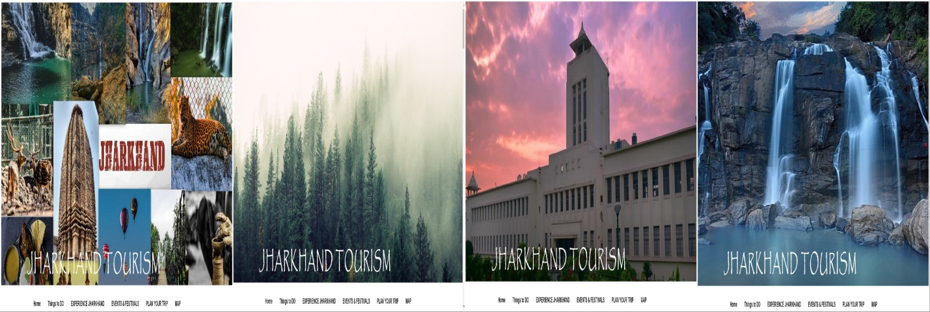

**Working**

We had used Javascript and Css to create this slide share . After each 4 second new image replaces the previous image and it work in loop for infinite time. We had used external Javascript for better convenience to access and both internal & inline Css to design the images routline .

**Navigation Bar**

It’s sticky menu-bar with hover drop-down option . as the pointer roll over the menu bar a dropdown menu option appear to the user with various content and link to those content . menu-bar contents are (i) Home

(ii) Things to Do

(iii) Experience Jharkhand

(iv) Event & Festival

(v) Plan Your Trip

(vi) Map

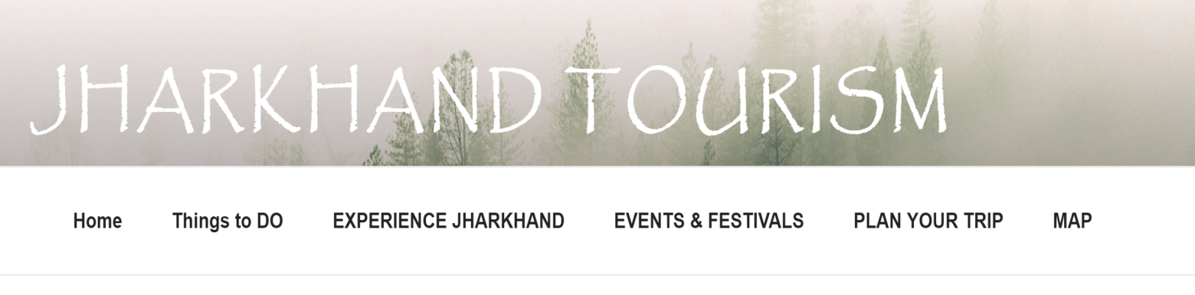

**HOME**

It had a default setting to restore any page to its original view , if user want to move to top from bottom or any section of our webpage they just need to click on home button.

**THINGS TO DO**

It’s a dropdown menu option for user for giving them idea about what can they do when they feel bored or not feeling to travel a lot , it provide a local guide for enjoyment .it had multiple options such as

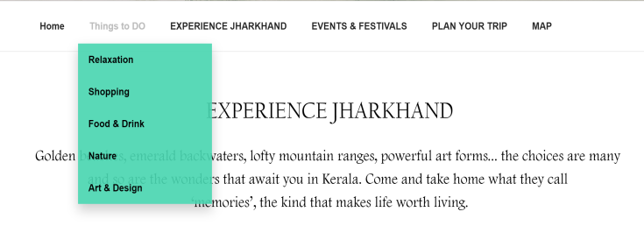

* **Relaxation**
* **Shopping**
* **Food & drink**
* **Nature**
* **Art & Design**

**Experience Jharkhand**

It’s a dropdown menu option for user for experiencing the real beauty of Leafy Timber , emerald backwaters, lofty mountain ranges, powerful art forms... the choices are many  and so are the wonders that await you in Jharkhand. Come and take home what they call  ‘memories’, the kind that makes life worth living

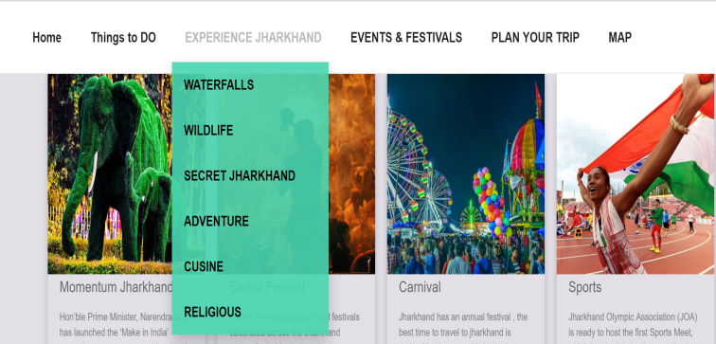

* **WATERFALL**
* **WILDLIFE**
* **SECRET JHARKHAND**
* **ADVENTURE**
* **CUISINE**
* **RELIGIOUS**

**Event & Festival**

A **festival** is an event ordinarily celebrated by a community and centering on some characteristic aspect of that community and its religion or cultures. It also feature dropdown feature with following categories

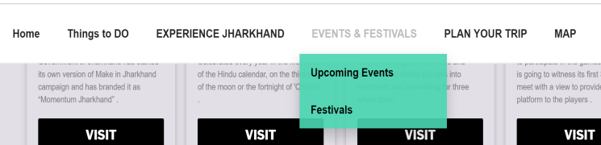

* **UPCOMING EVENTS**
* **FESTIVALS**

**Plan Your Trip**

Usually vacation are very short and very little graceful , Hey have no worries we are here for that too . Everything you need is here , you just need to click and we take care of the rest . we had provided various sections for user convenience which are

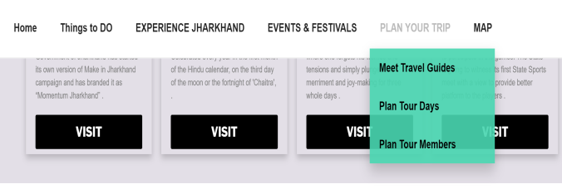

* **Meet travel guide**
* **Plan your trip**
* **Plan by members**

**Map**

Its is not always pleasant to travel by public transport or on common path same as others . a lone ride can make a memory which can never be forgotten . but with no guide it is just waste of time , so we are here for that too we are willing to provide as much as we can . this website contain google MAP for tracking roads , railway line , for comparing distance among diffrebt cities and much more ……..

**Working**

**BODY**

It contains the content of the page . It is middle section of webpage which is ……..

**EXPERIENCE JHARKHAND**

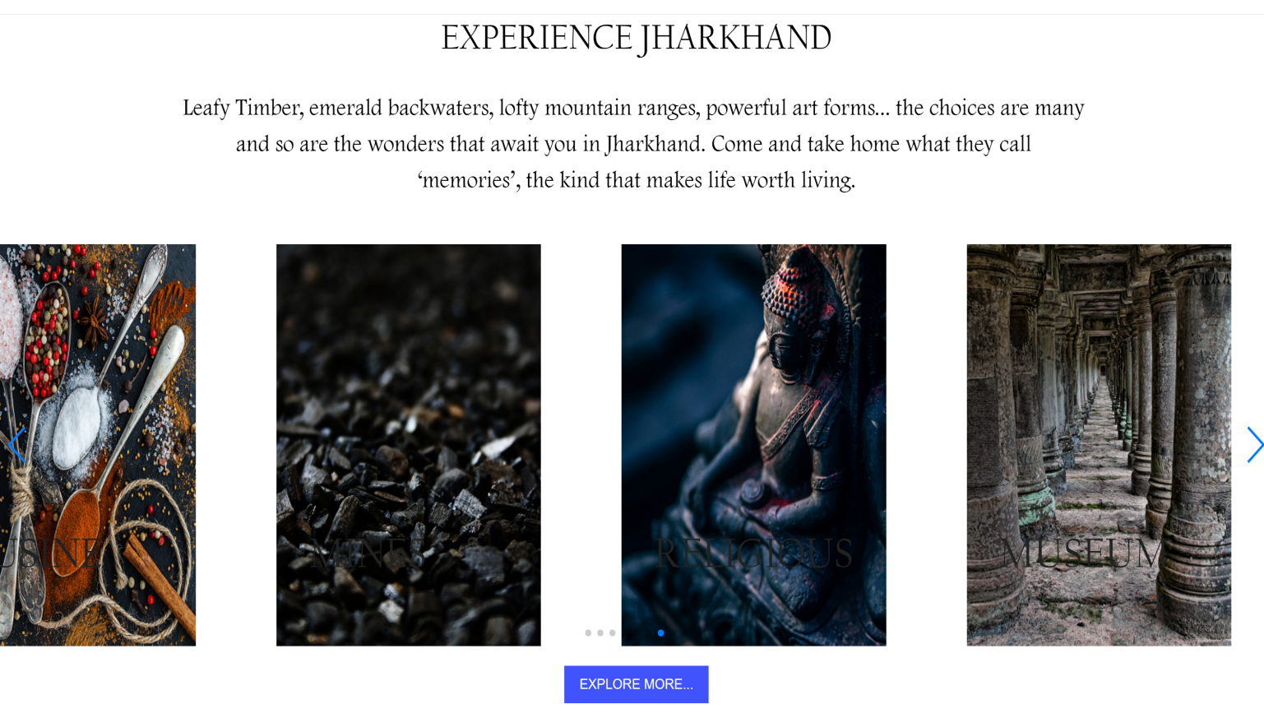

It’s a separate article section which had Slider as its key-portion . the slider contain 9 individual topic that are

1. WATERFALL: It is one of the best tourist attraction in “JHARKHAND”, covering a wide area of it travelers have great interest in these waterfall. As a link is provided for all the waterfalls tourist need to travel.
2. WILDLIFE: Wildlife, Jharkhand. Wildlife in Jharkhand is vivid, offering you a high level of thrill and jungle experience. Top Jharkhand Nature & Wildlife Areas: See reviews and photos of nature & wildlife areas in Jharkhand just click on the link provided.
3. SECRET JHARKHAND: These are hidden places of Jharkhand tourist need to visit as it gives the best experience of visiting and the part of there holiday.
4. ADVENTURE: **Jharkhand is rising amongst the preferred destinations for adventure tourists.**

* **Water** Sports at Giridih.
* Rock Climbing.
* **Hot Air** Balloon **Show**.
* Parasailing **at** Giridih.

1. LIVE- INDIGEOUS ational governments continue to deny **Indigenous** Peoples the right to **live** in and ... **IV**. International Instruments for the Protection of **Indigenous** Peoples.
2. CUISINE: A **cuisine** is a style of cooking characterized by distinctive ingredients, techniques and dishes, and usually associated with a specific culture or geographic. A different option are provided for the users to have a delicious food around here.
3. MINERALS : Jharkhand is **endowed** with vast natural resources **specially the** vast variety **of** minerals ranging **from** Iron ore**,** Coal, Copper ore, Mica, Bauxite**,** Fire clay, **Graphite,** Kyanite, Sillimanite**,** Lime stone**,** Uranium & other minerals**.** Jharkhand is the leading producer of mineral wealth in the country.
4. RELIGIOUS : Spirituals **Places** of **Jharkhand**, **Jharkhand religious** tour, **Jharkhand** Spirituals **Places**, **Religious places** of **Jharkhand**, Know about **Jharkhand** Spirituals **Places**.
5. MUSEUM : Top Jharkhand Museums: See reviews and photos of **museums in Jharkhand.** Famous **museums** in of **Jharkhand** - Location, Address, Contact Phone number, How to reach, Photos, Entry Fees - Get the complete information about all the places by just clicking on the link.

And a special button for exploring more of Experience Jharkhand

**WORKING**

**WHAT IS HAPPNING**

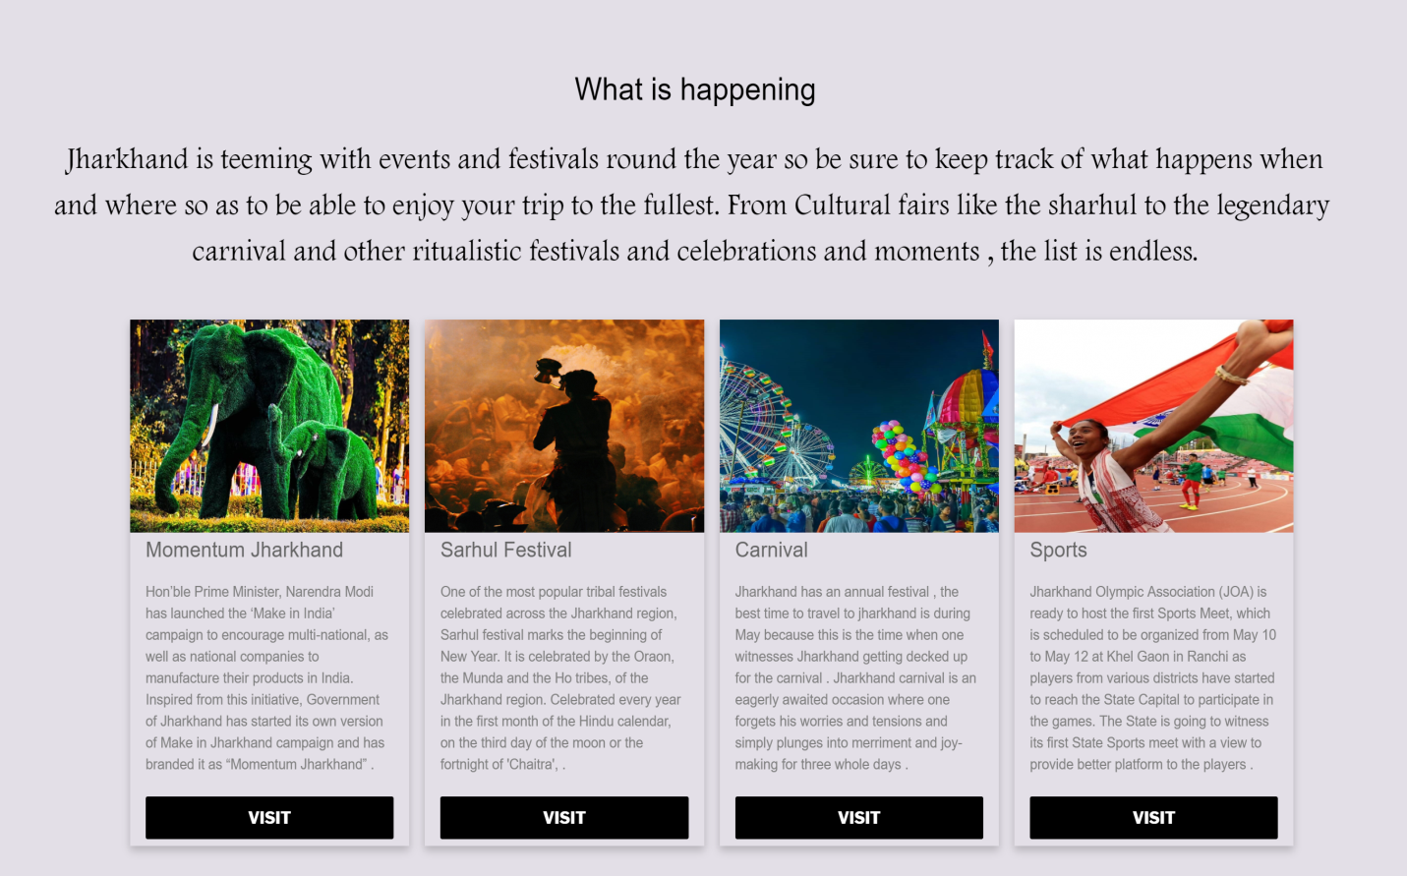

This content of the page simply defines the recent activities in the city.

1.It is an event or series of events designed to evoke a spontaneous reaction to sensory, emotional, or spiritual stimuli.

2. something (such as an event) that is particularly interesting, entertaining, or important.

MOMENTUM JHARKHAND:  The Investment Destination Hon'ble Prime Minister, Narendra Modi has launched the 'Make in India' campaign to encourage multi-national. Government of Jharkhand has started its own version of make of Jharkhand campaign, and has branded it as ‘MOMENTUM JHARKHAND’.

# SARHUL-FESTIVAL:**Sarhul festival** is one of the most popular festival celebrated across the **Jharkhand** region. 'Sar' refers to Year and 'Hul' means set to begin. The Sarna tribe in Jharkhand celebrates the Sarhul festival with great enthusiasm. The men and women of the Sarna tribe clad in colourful. These are the recent happening in the state.

# CARNIVAL: this is also known as ‘mela’ celebrated vividly across the place. **Carnival** is a Western Christian and Greek Orthodox festive season that occurs before the liturgical season of Lent.

SPORTS:These are the recent activities where Jharkhand is hosting an athletic meet for the first time in the history.

**Working**

**FAMOUS BY NAMES**

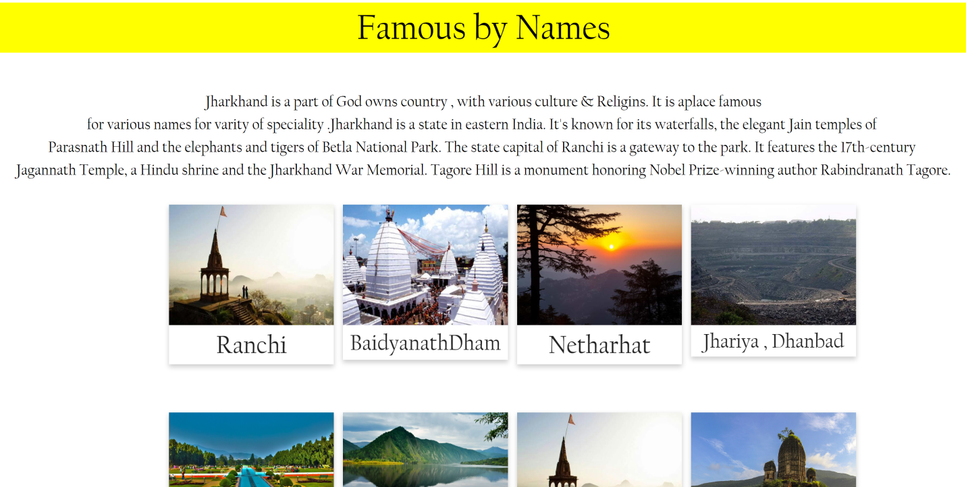

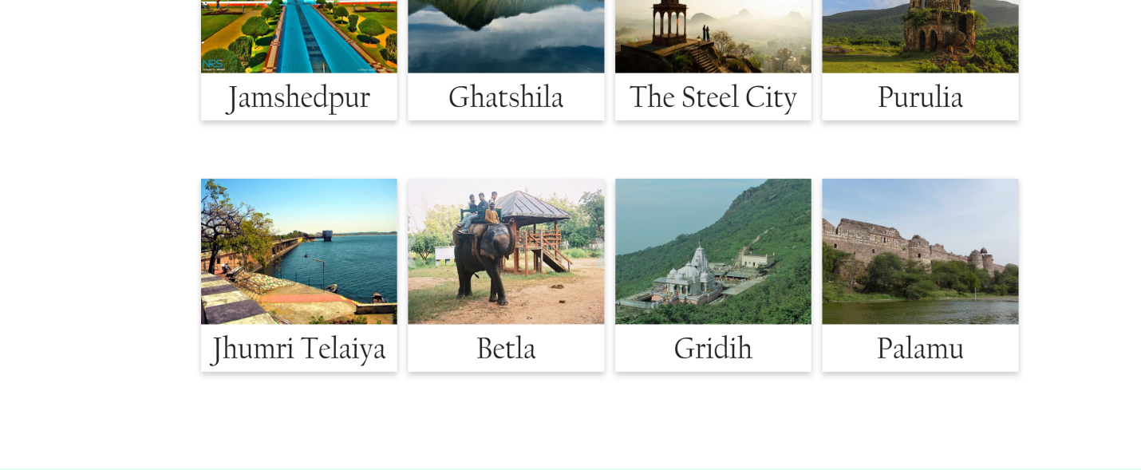

This page basically describes what is Jharkhand famous. Jharkhand is a state in eastern India. Famous by names are probably the best places a tourist can explore. Jharkhand has a rich variety of flora and fauna. The National Parks and the Zoological Gardens located in the state of Jharkhand present a panorama of this variety Hindi is the official language in Jharkhand and is spoken by the majority of the population (61.95%), although different regions have their own dialects.

RANCHI: Ranchi is the state capital of Jharkhand in northeast India. At the top of central Ranchi Hill, Pahari Mandir is a Hindu temple dedicated to Shiva, with panoramic city views. Nearby, leafy Nakshatra Van is a large park with trees planted to represent stars of the zodiac. The region is known for its tribal heritage, and exhibits at the Tribal Museum include musical instruments and jewelry from the state’s many tribes.

**area:**652 km²

**elevation:**651 m

**weather:**38 °C, Wind NW at 21 km/h, 17% Humidity

**population:**10.7 lakhs (2011)

BAIDYANATH DHAM: **Baidyanath Jyotirlinga temple**, also known as *Baba Baidyanath dham* and *Baidyanath dham* is one of the twelve jyotirilingas, the most sacred abodes of Shiva. It is located in Deoghar in the Santhal parganas division of the state of Jharkhand, India. It is a temple complex consisting of the main temple of Baba Baidyanath.

NETARHAT: **Netarhat** is a town in Latehar district in the Indian state of Jharkhand. Referred to as the "Queen of Chotanagpur", it is a popular hill station.

JHARIA: **Jharia** is a neighbourhood in Dhanbad in **Jharkhand** state, India. **Jharia** was the fifteenth-largest town in the state of **Jharkhand**. **Jharia** is famous for its rich coal.

JAMSHEDPUR: Jamshedpur is a large city set between the Subarnarekha and Kharkai rivers in the east Indian state of Jharkhand. It’s known for huge, tree-lined Jubilee Park, where the Tata Steel Zoological Park has resident species including tigers and leopards. To the east, the hilltop Bhuvaneshwari Temple has an elaborate 5-story entrance tower. North of the city, elephants roam through the forests at Dalma Wildlife Sanctuary.

weather**:**42 °C, Wind W at 11 km/h, 22% Humidity.

GHATSILA: Ghatshila is a town on the Subarnarekha River, in the east Indian state of Jharkhand. Set among forested hills, it’s home to Ghatsila Rankini Mandir, a temple dedicated to the goddess Kali and decorated with brightly painted carvings of Hindu deities. To the north, Phuldungri Hillock overlooks the town, and Burudi Lake is a popular picnic spot. Northwest, elephants and deer roam through Dalma Wildlife Sanctuary.

THE steel city: The Steel City is a common nickname for many cities that were once known for **their** production of large amounts of **steel**. With industrial production also in developing countries, like those in Eastern Europe and Asia, most of these cities do not produce as much steel as they used to.

PURULIA: Purulia district is one of the twenty three districts of West Bengal state in Eastern India. Purulia is the administrative headquarters of the district. Some of the other important towns of Purulia district are Raghunathpur-Adra, Jhalida and Balarampur.

**weather:**41 °C, Wind W at 14 km/h, 20% Humidity.

JHUMRI TELAIYA: Jhumri Telaiya is a city in the Koderma District of Jharkhand, India. It is situated in the Damodar Valley. Alternative English transliterations of the town's name include Jhumri Tilaiya, Jhumari Talaiya, and Jhumri Tilaiya.

**weather:**41 °C, Wind NW at 26 km/h, 12% Humidity

**population :**87,867 (2011)

BETLA: Betla National Park is a national park located on the Chhota Nagpur Plateau in the Latehar district of Jharkhand, India. The park hosts a wide variety of wildlife. The park provides several opportunities to observe a variety of wildlife at close range. There are elephant rides and jeeps available with guides for venturing inside the park. Watch towers and ground hides have been constructed to view the wildlife. The park is open throughout the year. Wildlife sightings are highest in the hot season (May to June), when foliage is not as thick. The most comfortable time to visit in terms of climate is between November and March.

GIRIDIH: Giridih is headquarters of the Giridih district of Jharkhand state, India. The literal meaning of Giridih is the land of hills and hillocks – giri, a Hindi word, means hills and dih, another word of the local dialect, indicates land of. Before 1972, Giridih was part of Hazaribagh district.

PALAMU: Palamau is one of the twenty-four districts of Jharkhand state, India. It was formed in 1892. The administrative headquarter of the district is Medininagar, situated on the Koel River. **Palamu** is a District in north-western Jharkhand, on the border of Districts Chatra in the east, Garhwa in the west, Latehar in the south

**Working**

**THINGS TO DO**

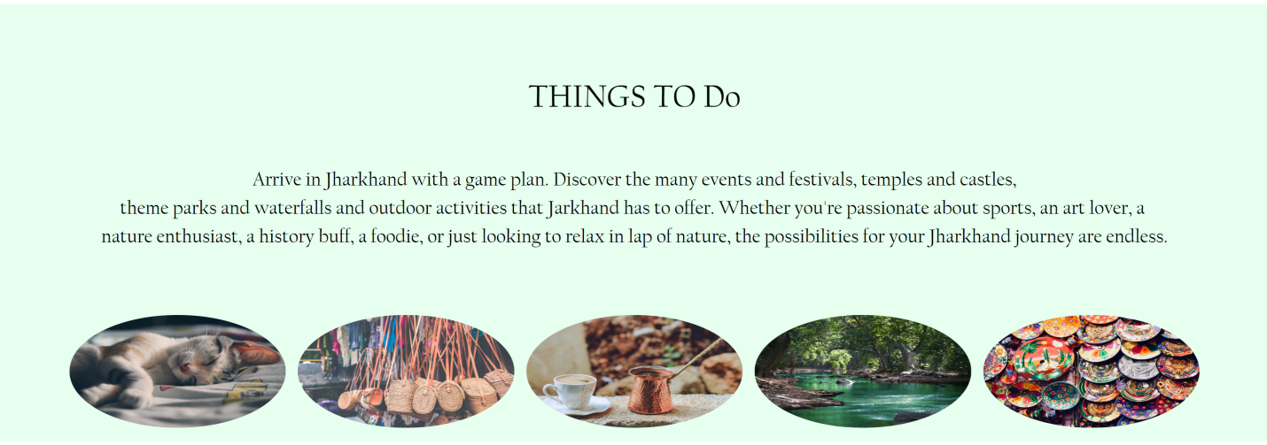

1.RELAXATION: This is the list of things visitor can do while visiting this city.

2.SHOPPING: Find new things to do near you.

3.FOODS AND DRINKS: Explore the top-rated attractions, tours and activities nearby

4.NATURE: With such a wide variety of things to do on the in this place during your holiday, you’ll want to come back again and again.

5. ART AND DESIGNS: View the list of all Fine **Arts** galleries in **Jharkhand** conducting Fine **Arts** exibition, top/ best Fine **Arts** institutes conducting Fine **Arts** courses in **Jharkhand** - Costume and Fashion **Designing** Colleges In **Jharkhand** and many more.

**Working**

**footer**

**FIND US**

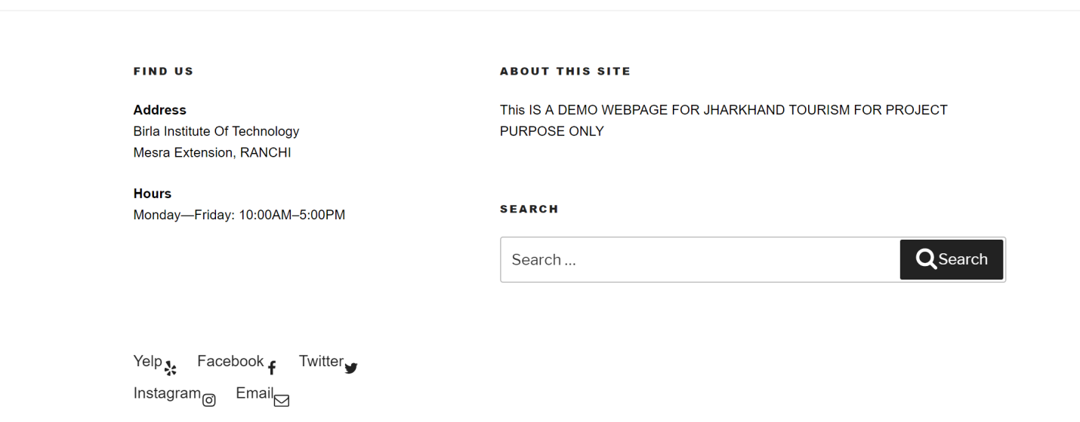

It is permanent address of the developers, where you can find us or contact with us.

The office has a fixed time for visitors to visit, and is opened and closed shortly.

Working

**ABOUT THE SITE**

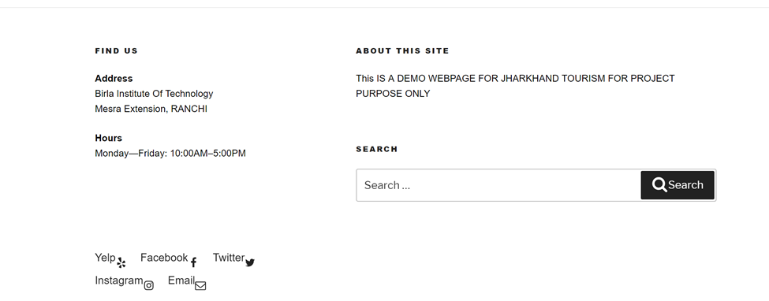

The details about our site is given right here.

Working

**SEARCH**



This search menu is given for searching anything relating to this site. Visitors with any query can search for in this.

Working

**SOCIAL MEDIA**



You can connect to your social media for finding your friends and to find the latest hot topic about the tourist places here in Jharkhand.

Working